

BSc Computer Science

Developing a Drug Prescription Service Based on a
Distributed Immutable Ledger Paradigm

Final Year Project Report

Author: Lamcy Jayesh Manwani
Student ID: 22063079
Supervisor: Paul Morris
Submission Date: 27-03-2026

Abstract
The integrity and security of drug prescription records represent a critical and persistent challenge in modern healthcare systems. Conventional prescription management platforms rely on centralised relational databases that, despite their operational efficiency, remain vulnerable to unauthorised modification, prescription fraud, and inadequate cross-institutional auditability. This project addresses these weaknesses through the design and implementation of a Drug Prescription Service grounded in the principles of a Distributed Immutable Ledger (DIL).
The development process involved significant architectural evolution informed by supervisor feedback. An initial over-engineered design separated cryptographic responsibilities across two distinct tables — a blockchain_ledger for audit ordering and a hash_records table for data integrity — creating duplicate hash workloads and unclear verification paths. Following supervisor guidance, the design was rationalised to a single authoritative hash mechanism: the blockchain_ledger became the sole source of cryptographic truth, with each block hash computed from action metadata, eliminating the need for a separate hash_records table. Similarly, an initial wide access_roles table with boolean columns was replaced by the normalised roles, permissions, and role_permissions structure, consistent with established RBAC principles.
The final system is implemented across a three-tier Python architecture — backend.py (business logic), main.py (CLI and GUI entry point), and interface.py (Tkinter GUI with full SHA-256 password authentication) — backed by a MySQL relational database hosted via XAMPP, containing 23 tables, 5 triggers, and 4 reporting views. Development followed an Agile methodology and encountered a significant setback when the XAMPP environment crashed due to insufficient storage mid-development, requiring a complete database rebuild. The rebuilt implementation is architecturally cleaner and incorporates all supervisor-directed improvements.
Testing confirmed that SHA-256 hash chain validation correctly detects tampered blocks, database-level triggers independently prevent blockchain record deletion, and dual audit logging across audit_log and security_audit_log provides comprehensive forensic coverage. The project demonstrates that a hybrid blockchain-SQL architecture, rationally designed around a single hash workload, represents a credible and academically defensible model for securing healthcare prescription records.

Acknowledgements
I would like to express my sincere gratitude to my project supervisor, Paul Morris, for his consistent guidance, constructive critical feedback, and patience throughout the development of this project. His identification of the over-engineering in the initial hash design and the access_roles table structure were pivotal interventions that substantially improved the academic and technical quality of the final system.
I would also like to thank the academic staff at university of Hertfordshire for providing the foundational knowledge in computer science, database systems, software engineering, and cryptography that made this work possible.
Finally, I acknowledge the open-source communities behind MySQL, Python, Tkinter, and XAMPP whose tools formed the development foundation of this project.

Table of Contents
Abstract 2
Acknowledgements 3
Table of Contents 4
List of Figures and Tables 5
1. Introduction 6
1.1 Background and Motivation 6
1.2 Problem Statement 7
1.3 Aims and Objectives 8
1.4 Research Questions 8
1.5 Scope and Limitations 9
1.6 Report Structure 9
2. Literature Review 10
2.1 Prescription Management — Current Challenges 10
2.2 Blockchain and DIL Technology 11
2.3 Blockchain Applications in Healthcare 12
2.4 Hybrid Blockchain-SQL Architectures 13
2.5 Cryptographic Hashing and Data Integrity 13
2.6 Role-Based Access Control 14
2.7 Summary and Justification 15
3. Methodology 16
3.1 Research Approach 16
3.2 Agile Development 16
3.3 Requirements Analysis and MoSCoW 17
3.4 Tools and Technologies 18
3.5 System Architecture Overview 21
3.6 Ethical Considerations 21
4. System Design and Implementation 22
4.1 Database Design and Schema 22
4.2 Design Evolution — Supervisor Feedback and Rationalisation 24
4.3 Blockchain Layer — Rationale Hash Design 26
4.4 Trigger Implementation and Immutability 27
4.5 Role-Based Access Control Model 28
4.6 Three-Tier Python Architecture 29
4.7 Backend Module (backend.py) 29
4.8 Application Entry Point (main.py) 30
4.9 Graphical User Interface (interface.py) 31
4.10 Security Implementation 32
5. Testing and Results 33
5.1 Testing Strategy 33
5.2 Unit Testing 33
5.3 Integration Testing 34
5.4 Blockchain Validation Testing 34
5.5 Security Testing 35
5.6 Summary of Results 35
6. Discussion 36
7. Conclusion 38
8. Critical Reflection 39
References 42
Appendices 45

List of Figures and Tables
Figures
Figure 1 — Four-Layer System Architecture 21
Figure 2 — Entity-Relationship Diagram (ERD) 23
Figure 3 — Blockchain Hash Chain Structure 26
Figure 4 — Role-Based Access Control Model 28
Figure 5 — Agile Development Sprint Structure 17
Figure 6 — Three-Tier Python Module Architecture 29
Figure 7 — Design Evolution — Original vs Rationalised Hash Architecture 25
Figure 8 — Login Screen — Tkinter GUI 31
Figure 9 — Dashboard — Tkinter GUI 32
Figure 10 — Blockchain Validation Output 34
Figure 11 — Audit Log Screen 35
Tables
Table 1 — MoSCoW Requirements Specification 17
Table 2 — Tools and Technologies Summary 20
Table 3 — Original vs Rationalised Design Comparison 25
Table 4 — Unit Test Results 33
Table 5 — Database Table Summary 45
Table 6 — Python Functions Summary 46

Chapter 1: Introduction

1.1 Background and Motivation
The management of drug prescriptions is one of the most sensitive and operationally critical processes within modern healthcare delivery. Across hospitals, clinics, and pharmacies, prescription records form the evidentiary basis for medication dispensing, patient safety monitoring, and regulatory compliance. Yet in the majority of existing healthcare systems, these records are maintained in isolated, institution-specific databases that offer limited transparency, weak cross-institutional auditability, and insufficient protection against data manipulation (Agbo, Mahmoud and Eklund, 2019).
A primary motivation for this project was a genuine personal concern about the state of healthcare data management in the United Kingdom. The NHS and the broader UK healthcare system, despite substantial investment in digital infrastructure, continue to struggle with fragmented and siloed record systems. Prescription fraud alone costs the NHS an estimated hundreds of millions of pounds annually, and the consequences for individual patients — including medication errors, duplicate dispensing, and unsafe drug combinations — are well-documented (Esposito et al., 2018). The desire to contribute something technically meaningful to a domain where good engineering directly improves patient safety and reduces institutional harm drove the selection of this topic.
Beyond the practical motivation, this project offered an opportunity to explore a set of technologies at the intersection of cryptography, database engineering, and distributed systems — areas of deep personal technical interest. The idea that blockchain-inspired structures could provide a mathematically verifiable guarantee of data integrity, applied to a domain as consequential as medical prescriptions, felt both intellectually compelling and socially worthwhile. As Crosby et al. (2016) observe, the properties of tamper-evidence, transparency, and cryptographic auditability that characterise distributed ledger technology are precisely the properties that healthcare record management most urgently requires.
The concept of a Distributed Immutable Ledger (DIL) provides the architectural response to these challenges. Originating in the cryptocurrency domain through the foundational work of Nakamoto (2008), distributed ledger technology stores data in cryptographically linked blocks where each record is hashed and chained to the previous one. Any attempt to alter a historical entry invalidates the hash chain, rendering tampering immediately and mathematically detectable. This project applies these principles within a hybrid architecture that is practically implementable, academically rigorous, and directly relevant to a healthcare system that needs better tools for ensuring the integrity of its prescription records.

1.2 Problem Statement
Traditional drug prescription systems rely on centralised relational databases managed by individual healthcare institutions. These systems suffer from four principal weaknesses that this project addresses.
First, they provide no inherent mechanism for detecting whether records have been tampered with after creation. A database administrator or compromised privileged account can alter prescription records without leaving any cryptographically verifiable trace. Second, they offer no cross-institutional transparency — a prescription issued at one provider is invisible to another, enabling duplicate or fraudulent prescriptions to go undetected. Third, audit trails in conventional systems are stored within the same database they are auditing, making them subject to identical manipulation risks (Zheng et al., 2017). Fourth, access control in many systems is insufficiently granular, failing to enforce meaningful distinctions between the privileges of administrators, clinicians, and dispensing staff.
This project addresses each of these weaknesses through a hybrid blockchain-SQL prescription management system in which tamper-resistance is enforced at both the application layer and the database layer, and in which role-based access control governs every user interaction.

1.3 Aims and Objectives
The overarching aim is to design, implement, and critically evaluate a secure drug prescription management system that applies the principles of a Distributed Immutable Ledger to improve data integrity, transparency, and tamper-resistance in healthcare record management (Crosby et al., 2016). This aim is pursued through the following objectives:
- To investigate the data requirements of drug prescription workflows and design a fully normalised relational database in MySQL supporting multi-role prescription management.
- To implement SHA-256 cryptographic hash chaining using a single, rationalised hash mechanism that serves as the sole authoritative source of cryptographic truth.
- To enforce immutability at the database level through MySQL triggers that prevent deletion of blockchain records independently of the application layer.
- To implement a normalised role-based access control framework using separate roles, permissions, and role_permissions tables in place of a flat boolean access structure.
- To develop a modular three-tier Python architecture — backend.py, main.py, interface.py — with full SHA-256 password authentication and dual-mode CLI and GUI access.
- To implement comprehensive dual-layer audit logging across audit_log and security_audit_log, capturing all significant system events.
- To test the system rigorously and evaluate its performance critically, including an honest assessment of design evolution, limitations, and the influence of supervisor feedback.

1.4 Research Questions
- To what extent can blockchain-inspired cryptographic hashing and chain-linking mechanisms enforce tamper-resistance when implemented within a centralised relational database environment?
- How effectively does a hybrid blockchain-SQL architecture, rationalised around a single hash workload, balance data integrity, performance, and clinical usability?
- What are the principal security limitations of a simulated distributed ledger compared to a fully decentralised blockchain network, and how can these be mitigated?

1.5 Scope and Limitations
The scope encompasses the full development lifecycle of a functional prescription management prototype: requirements analysis, system design, implementation, testing, and critical evaluation. The system supports four user roles, a drug and inventory management module, a blockchain-inspired ledger with chain validation, and a graphical user interface with password-authenticated login.
The project does not implement a fully decentralised blockchain network. Such an implementation would introduce infrastructure complexity, latency, and cost barriers incompatible with the scope of an undergraduate prototype (Esposito et al., 2018). Questions of UK GDPR compliance, NHS data standards, and clinical governance are acknowledged but outside the prototype's scope.

1.6 Report Structure
Chapter 2 provides a critical literature review. Chapter 3 presents the methodology, including the Agile approach, requirements analysis, and the complete design evolution from initial plan through supervisor-directed rationalisation. Chapter 4 describes system design and implementation across all architectural layers, with dedicated discussion of the hash design evolution. Chapter 5 presents testing and results. Chapter 6 discusses findings. Chapter 7 draws conclusions. Chapter 8 provides critical reflection including the XAMPP crash and rebuild. References and appendices follow.

Chapter 2: Literature Review

2.1 Prescription Management — Current Challenges
The fragmentation of prescription data across healthcare institutions represents one of the most persistent structural problems in modern medical records management. In the United Kingdom, prescription records are typically maintained by individual providers in proprietary systems that do not interoperate, creating information silos that impede care continuity and enable prescription misuse (Agbo, Mahmoud and Eklund, 2019). The NHS Electronic Prescription Service has made progress in digitising workflows, yet the fundamental vulnerability of centralised database architectures to internal tampering remains unresolved (Esposito et al., 2018).
Zheng et al. (2017) identify three risk categories in conventional systems: external attack, internal manipulation by privileged users, and systemic failure from absent cross-institutional visibility. Kumar, Tripathi and Marchang (2020) extend this analysis, noting that audit trails stored within the same database they audit are subject to identical manipulation risks — the self-referential weakness that blockchain immutability is designed to resolve.

2.2 Blockchain and Distributed Immutable Ledger Technology
The conceptual foundation of blockchain was established by Nakamoto (2008). The core innovation was the construction of a distributed ledger in which transactions are grouped into blocks, each containing a cryptographic hash of its contents and a reference to the hash of the preceding block. Altering any historical record requires recalculating all subsequent hashes — computationally infeasible in a sufficiently distributed network.
Crosby et al. (2016) distinguish public permissionless, private permissioned, and consortium chain architectures. For healthcare applications, public chains are generally unsuitable for direct data storage due to insufficient privacy controls for personal health information (Esposito et al., 2018). It is important to acknowledge that a true blockchain network is not simply a chain of linked hashes — it is a distributed system in which multiple independent nodes each hold a copy of the ledger, and in which no single node has the authority to alter records without the agreement of the wider network. This distributed verification is enforced through consensus mechanisms: Proof of Work (PoW), used by Bitcoin, requires nodes to expend significant computational effort to validate each block, making retrospective alteration computationally infeasible across the full network (Nakamoto, 2008); Proof of Stake (PoS) selects validators based on their stake in the network, providing similar tamper-resistance with lower energy cost; and Practical Byzantine Fault Tolerance (PBFT), more commonly used in permissioned healthcare chains, requires agreement from a defined quorum of authorised nodes before any transaction is committed (Zheng et al., 2017). The critical distinction for this project is that these mechanisms derive their security not from cryptographic hashing alone, but from the impossibility of controlling a sufficient proportion of the network simultaneously. A centralised implementation that uses identical hash-chaining without distributed nodes and consensus provides tamper-evidence but not tamper-prevention at the network level — a limitation explicitly acknowledged in this project's scope and discussed in the evaluation chapter.

2.3 Blockchain Applications in Healthcare
Agbo, Mahmoud and Eklund (2019) conducted a systematic review identifying 34 blockchain healthcare studies, concluding the technology offers meaningful potential for data integrity, consent management, and cross-institutional sharing. The majority of implementations remain at prototype stage. Esposito et al. (2018) offer a nuanced assessment: while immutability is genuinely valuable for audit integrity, blockchain introduces governance complexity and key management challenges. Their recommendation of off-chain storage with on-chain hash verification directly informed this project's architectural approach.
Kumar, Tripathi and Marchang (2020) present a prescription management system sharing conceptual overlap with the present project. Their evaluation identifies performance under load and key revocation as primary unsolved challenges.

2.4 Hybrid Blockchain-SQL Architectures
The hybrid approach — blockchain for immutability and auditability combined with a relational database for operational data — is the dominant architectural recommendation in the healthcare blockchain literature (Khanna and Kaur, 2019; Kumar, Tripathi and Marchang, 2020). Connolly and Begg (2014) provide the normalisation and referential integrity framework underpinning the relational component. Elmasri and Navathe (2016) inform the entity-relationship modelling. Pour (2007) justifies MySQL selection over Oracle for academic prototyping contexts.
A critical insight from the literature, validated by supervisor feedback during this project, is that hybrid architectures must avoid over-engineering the cryptographic layer. Bass, Clements and Kazman (2012) emphasise that security architecture should be minimal, verifiable, and non-redundant — adding more hashes does not improve security if it creates ambiguity about which hash represents the authoritative state.

2.5 Cryptographic Hashing and Data Integrity
Cryptographic hashing produces a fixed-length digest from an arbitrary input such that even a single-character change produces a completely different output — the avalanche effect — making hash functions ideal for tamper detection (Menezes, van Oorschot and Vanstone, 1996). This project employs SHA-256, standardised by NIST (2015), which produces a 64-character hexadecimal digest computationally resistant to both pre-image and collision attacks.
A key design principle, reinforced through supervisor feedback, is that cryptographic verification should follow a single workload model: one hash per action, one verification path, one table as the authoritative source of truth. Krawczyk, Bellare and Canetti (1997) similarly argue that keyed hash constructions derive their security from simplicity and verifiability, not from multiplicity. This principle directly shaped the rationalisation of the initial over-engineered hash design described in Chapter 4.

2.6 Role-Based Access Control in Secure Systems
Role-Based Access Control (RBAC) assigns permissions to roles rather than directly to users, simplifying administration and reducing privilege escalation risk (Sandhu et al., 1996, cited in Bass, Clements and Kazman, 2012). Sommerville (2015) identifies role separation as a foundational requirement of secure system design in safety-critical domains. Pressman and Maxim (2014) specifically caution against flat boolean permission tables — their 'wide table' anti-pattern creates maintenance complexity and resists extension — advocating instead for normalised bucket structures where roles, permissions, and their mappings are held in separate, single-responsibility tables.
This guidance directly informed the correction of the initial access_roles table in this project, replacing boolean columns with the normalised roles, permissions, and role_permissions structure described in Chapter 4.

2.7 Summary and Justification
The literature consistently recommends a hybrid architecture combining blockchain immutability with a relational database for operational data as the most viable model for healthcare prescription management (Khanna and Kaur, 2019; Kumar, Tripathi and Marchang, 2020). The present project implements this model while explicitly incorporating the additional principle — confirmed through supervisor feedback — that the cryptographic layer must be minimal and non-redundant. The following chapter describes the methodology through which these design decisions were operationalised, including the significant architectural evolution that occurred during development.

Chapter 3: Methodology

3.1 Research Approach
This project adopts a design science research methodology, in which the primary contribution is an artefact — the prescription management system — evaluated against clearly defined functional and security requirements (Hevner et al., 2004, cited in Sommerville, 2015). No real patient data was collected at any stage; all testing used synthetically generated data.

3.2 Development Methodology — Agile
The system was developed using an Agile methodology structured around iterative two-week sprints (Beck et al., 2001). Agile was selected over a traditional Waterfall model because the project's requirements were expected to evolve as technical understanding deepened — a prediction that proved accurate when supervisor feedback prompted significant architectural rationalisation during mid-development (Highsmith, 2009).
Development proceeded through five phases: requirements gathering and system design; core database implementation; Python backend development; Tkinter GUI development; and testing, evaluation, and report writing. A critical unplanned event occurred between the second and third phases: the XAMPP development environment crashed due to insufficient local storage space, requiring a complete database rebuild. This incident is documented fully in Chapter 8.
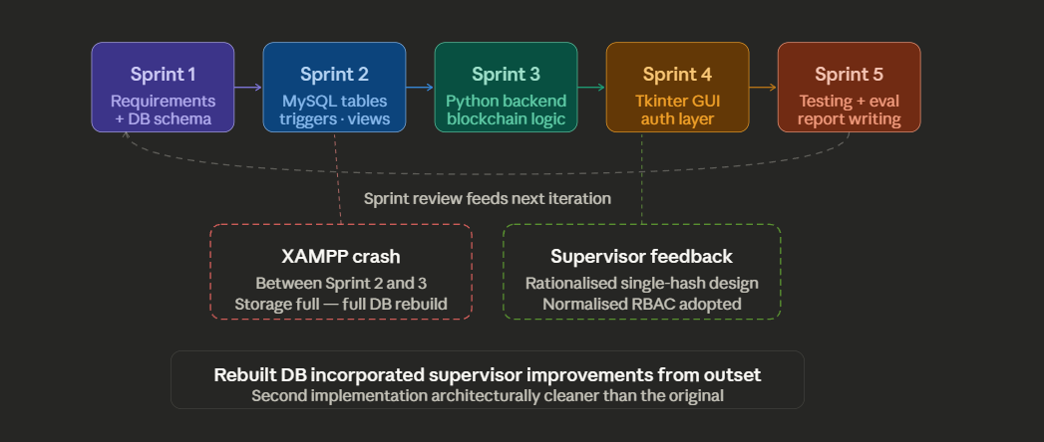
Figure 5: Agile Development Sprint Structure (including XAMPP crash event)

3.3 Requirements Analysis and MoSCoW Prioritisation
Requirements were elicited through structured analysis of the prescription management domain, informed by the Chapter 2 literature review and by supervisor feedback received during the design phase. The MoSCoW framework categorised requirements to focus development effort on the most critical features (Highsmith, 2009). Notably, the supervisor's feedback prompted two requirements to be reclassified: the original dual-hash architecture was reclassified from Must Have to Won't Have (replaced by the single-hash rational design), and the flat boolean access_roles table was reclassified from Must Have to Won't Have (replaced by normalised RBAC tables).

Priority | Requirement | Category
Must Have | User authentication with SHA-256 password hashing | Security
Must Have | Prescription creation and storage in MySQL | Functional
Must Have | Single-mechanism SHA-256 hash chaining (blockchain_ledger as sole source) | Blockchain
Must Have | Dual audit logging (audit_log + security_audit_log) | Security
Must Have | Block sealing after 6 transactions | Blockchain
Must Have | Chain validation — hash and chain integrity checks | Blockchain
Must Have | DB triggers preventing deletion of blockchain records | Security
Must Have | Normalised RBAC (roles, permissions, role_permissions) | Security
Should Have | Graphical user interface (Tkinter) | Interface
Should Have | Dual-mode entry point (CLI + GUI via main.py) | Interface
Should Have | Three-tier Python module architecture | Architecture
Should Have | Drug, dosage, quantity capture in transactions | Functional
Should Have | Failed login tracking across multiple tables | Security
Could Have | Drug inventory and stock management module | Functional
Could Have | Role-specific dashboard navigation in GUI | Interface
Won't Have | Dual-hash architecture (blockchain_ledger + hash_records) | Architecture
Won't Have | Flat boolean access_roles table | Architecture
Won't Have | Full decentralised blockchain network | Architecture

Table 1: MoSCoW Requirements Specification (reflecting supervisor-directed revisions)

3.4 Tools and Technologies — Justification
Initial Plan and Transition to XAMPP
The original project outline proposed a standalone Python environment connected directly to a MySQL server with a Flask web frontend. This configuration was selected on the basis of Python's cryptographic library support and Flask's lightweight web capabilities (Grinberg, 2018). During early development, managing the database server, Python environment, and web server as independent processes introduced unnecessary configuration overhead.
Following a practical assessment of available tools, the decision was made to transition to XAMPP as the primary development platform. XAMPP bundles Apache, MySQL (MariaDB 10.4.32), and PHP into a single integrated local server environment with phpMyAdmin for schema design, trigger inspection, and data verification (Apache Friends, 2024). This transition simplified the development workflow substantially, allowing more time to be allocated to the blockchain and security components that constitute the project's academic core.
The frontend implementation also evolved from the originally planned HTML/CSS web interface to a Tkinter desktop GUI. Tkinter, as Python's native GUI library, allowed the entire application to be maintained within a single Python codebase. As the system matured, the architecture was further refined into three distinct Python modules, providing a clean separation of concerns consistent with established software engineering principles (Pressman and Maxim, 2014).
Technology Justification Summary
Technology | Role in System | Justification
MySQL via XAMPP (MariaDB 10.4.32) | Relational database | Open-source, web-optimised, prior familiarity (Pour, 2007)
Python 3 | Backend + blockchain logic | Strong cryptographic libraries, academic alignment (Ramalho, 2015)
Tkinter | Graphical user interface | Native Python GUI, no external dependencies
XAMPP | Development environment | Integrated stack, phpMyAdmin for DB administration
SHA-256 (MySQL SHA2 + hashlib) | Block hashing + password auth | NIST-standardised, single-mechanism design (NIST, 2015)
mysql-connector-python | Database connectivity | Official MySQL connector for Python
backend.py (custom module) | Separation of concerns | Isolates DB/blockchain logic from UI and entry point

Table 2: Tools and Technologies Summary

3.5 System Architecture Overview
The system follows a four-tier layered architecture: the Presentation Layer (Tkinter GUI in interface.py), the Application Layer (blockchain and business logic in backend.py, orchestrated by main.py), the Data Layer (MySQL via XAMPP containing 23 tables, 5 triggers, and 4 views), and the Blockchain Layer (hash computation and chain validation in the application tier; deletion prevention and modification auditing in the data tier). This modular structure ensures each component has clearly defined responsibilities (Pressman and Maxim, 2014; Sommerville, 2015).
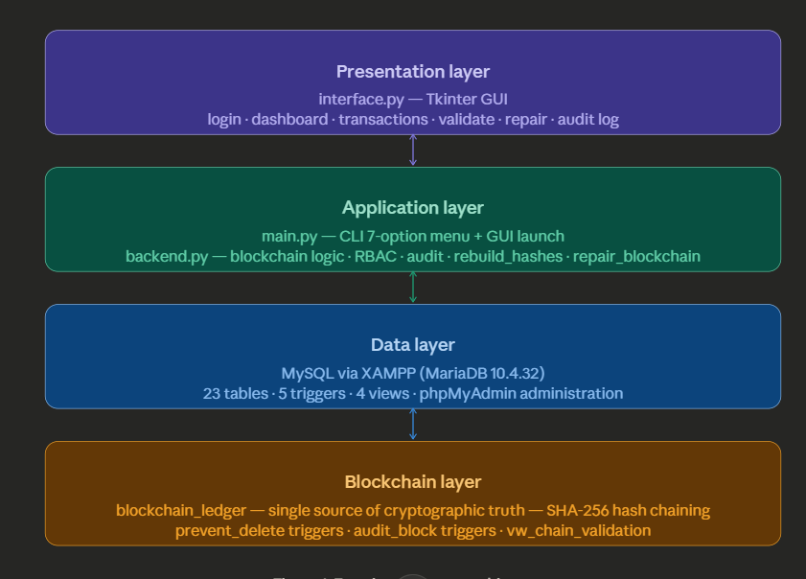
Figure 1: Four-Layer System Architecture

3.6 Data Collection and Ethical Considerations
This project does not involve the collection of real patient data. All data used during development and testing was synthetically generated. No personal health information was stored, processed, or transmitted. Ethical considerations relevant to real-world deployment — including UK GDPR, the Data Protection Act 2018, and NHS data security standards — are acknowledged here and discussed in the evaluation chapter, but fall outside the scope of this prototype.

Chapter 4: System Design and Implementation

4.1 Database Design and Schema
The final database schema, confirmed from the SQL dump (prescription_system.sql, exported via phpMyAdmin on 26 March 2026), comprises 23 tables, 5 triggers, and 4 reporting views, organised across four functional domains. The server version is MariaDB 10.4.32, hosted via XAMPP on localhost.
User Management Domain
The master users table stores user_id, username, password_hash (VARCHAR 255, storing SHA-256 credential hashes), email, phone, role (ENUM: admin, doctor, pharmacist, patient), and role_id as a foreign key to the roles table. Four role-specific tables — admin_users, doctor_users, pharmacist_users, and patient_users — extend this with role-specific attributes. The doctor_specialities table holds medical speciality reference data.
Prescription and Drug Management Domain
The prescriptions table records prescription_id, patient_id, doctor_id, date_issued, and status (ENUM: issued, dispensed, cancelled). The prescription_items table holds individual drug line items per prescription. The dispensing_records table captures pharmacy dispensing events. The drugs, drug_categories, and drug_stock tables support the drug inventory module. The pharmacies table records institutional pharmacy entities.
Blockchain and Ledger Domain
Three tables implement the blockchain layer. The blockchain_blocks table stores block_id, previous_hash (CHAR 64), block_hash (CHAR 64), created_at, and is_sealed (TINYINT 1, defaulting to 0). The blockchain_transactions table records individual transactions within blocks, including block_id, action_type, user_id, reference_table, reference_id, and transaction_data. The blockchain_ledger table — the rationally designed single source of cryptographic truth — stores block_id, previous_hash, block_hash, action_type (ENUM: create_prescription, dispense, modify, cancel), user_id, reference_table, reference_id, and created_at. The design and evolution of this table is discussed in full in Section 4.2.
Security and Audit Domain
The audit_log table records user_id, action (VARCHAR 100), target_table, target_id, and timestamp. The security_audit_log provides a dedicated security event trail. The failed_logins table captures authentication failures. The system_notifications table supports in-app alerts. The roles, permissions, and role_permissions tables implement the normalised RBAC framework. Four reporting views provide operational visibility: vw_audit_monitoring, vw_block_summary, vw_block_transaction_summary, and vw_chain_validation.
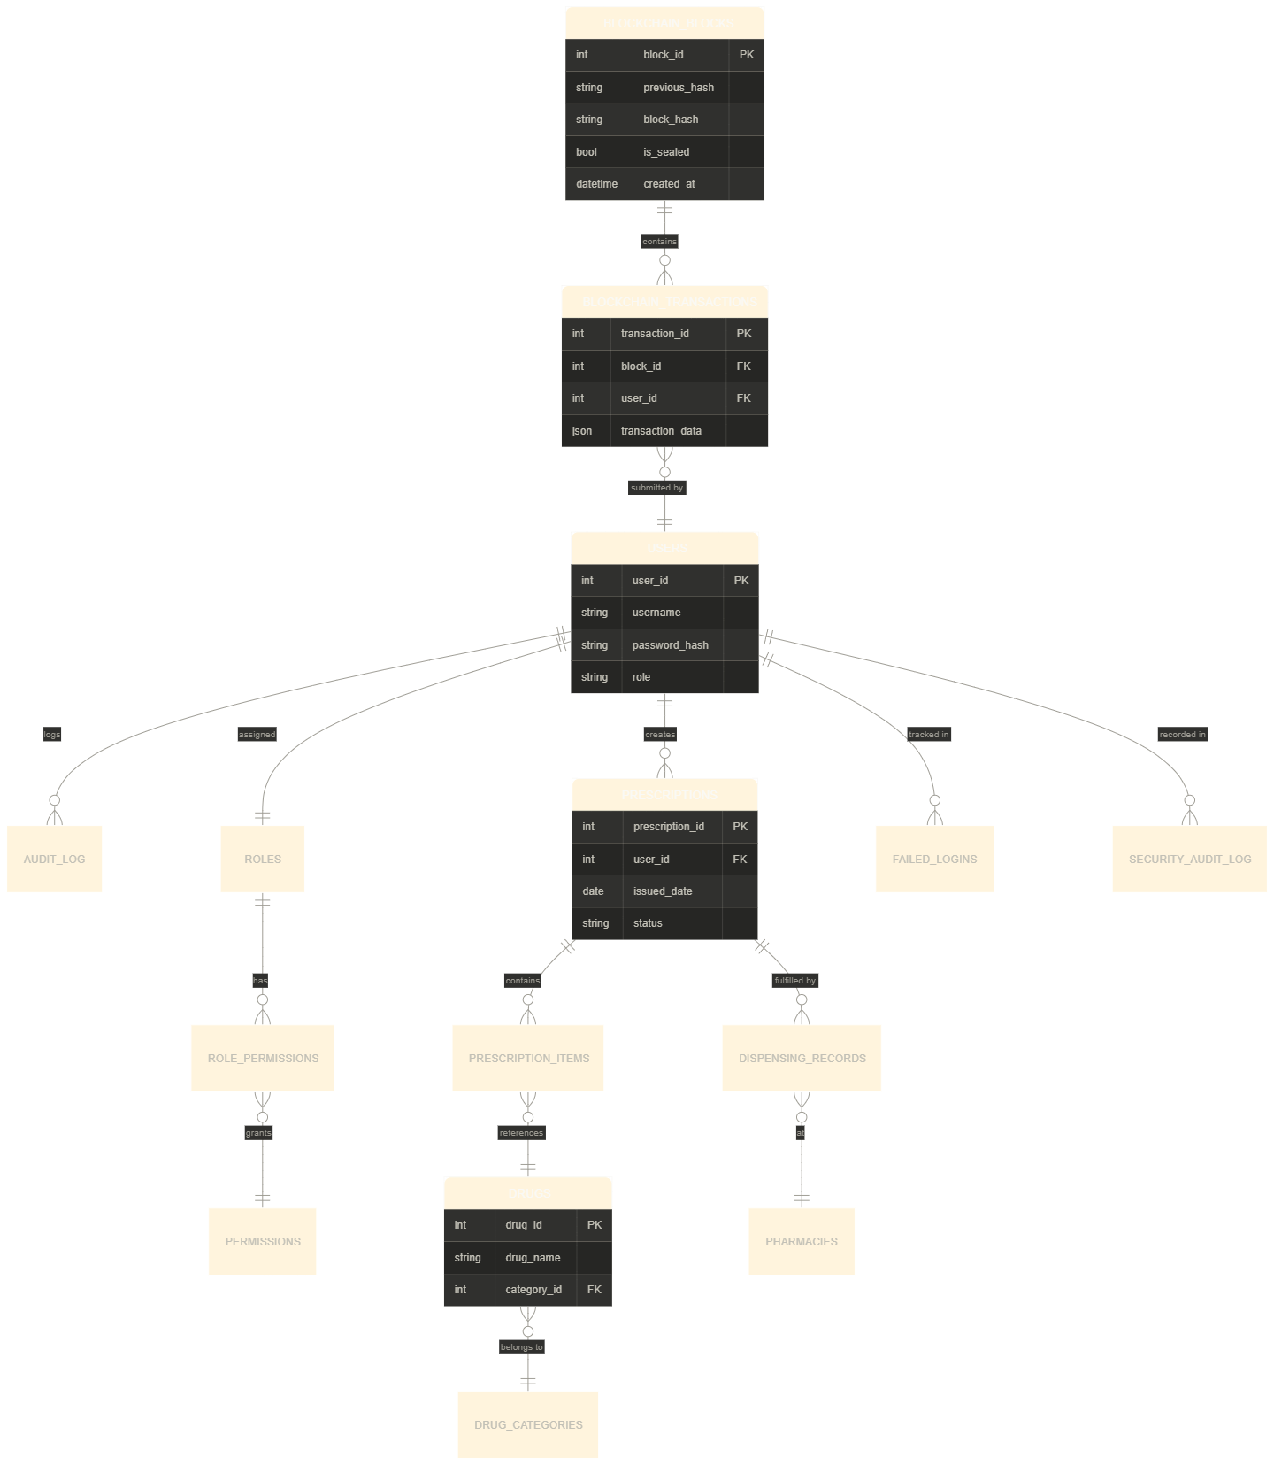
Figure 2: Entity-Relationship Diagram (ERD) — final confirmed schema

4.2 Design Evolution — Supervisor Feedback and Rationalisation
One of the most intellectually significant aspects of this project's development was the architectural evolution prompted by supervisor feedback during the database design phase. The initial design contained two significant structural problems that the supervisor identified as over-engineering — problems that, once understood, led to a fundamentally cleaner and more academically defensible system.
Problem 1 — Dual Hash Architecture
The original design separated cryptographic responsibilities across two tables. The blockchain_ledger was intended as an audit and ordering mechanism, recording who did what and when, with previous_hash and block_hash fields providing chain-linking. A separate hash_records table was intended as a data integrity mechanism, storing cryptographic fingerprints of the actual business data — prescriptions, dispensing records — to detect whether any record had been modified after creation.
The reasoning behind this separation was initially logical: it treated audit ordering and data integrity as two distinct security responsibilities, each deserving its own mechanism. However, the supervisor correctly identified this as creating two workloads doing cryptographic work simultaneously — a situation where the same data was effectively hashed twice, through different paths, creating ambiguity about which hash represented the authoritative state and making validation logic unnecessarily complex. If the blockchain_ledger hash and the hash_records hash disagreed, it was unclear which to trust and which to recalculate first.
Problem 2 — Boolean Access Roles Table
The initial access control design used a single access_roles table with boolean columns for can_read, can_write, and can_modify. This flat structure created what Pressman and Maxim (2014) describe as a wide table anti-pattern: the table was difficult to extend (adding a new permission type required altering the table schema), hard to query efficiently, and conceptually conflated the identity of a role with the definition of its permissions.
The Rationalisation
Following supervisor guidance, both structures were corrected. The hash_records table was eliminated entirely. The blockchain_ledger was redesigned as the single, authoritative source of cryptographic truth: each block hash is computed from the combination of previous_hash, action_type, user_id, reference_table, reference_id, and created_at. This means the hash implicitly commits to the state of the referenced data at the time of the transaction — if the referenced prescription or dispensing record is subsequently modified, a recomputed hash will differ from the stored value, detecting the tampering. One hash. One workload. One verification path.
The access_roles table was replaced by the normalised roles, permissions, and role_permissions structure. Each table has a single responsibility: roles defines what roles exist; permissions defines what actions are possible; role_permissions maps the many-to-many relationship between them. This is the standard RBAC normalisation recommended by Sommerville (2015) and provides clean extensibility — adding a new permission requires only a new row in permissions and a new mapping in role_permissions, with no schema alteration.

Aspect | Original Design (Over-engineered) | Rationalised Design (Final)
Hash storage | Two tables: blockchain_ledger + hash_records | Single table: blockchain_ledger only
Hash workloads | Two independent cryptographic paths | One hash per action, one verification path
Verification logic | Ambiguous — which hash is authoritative? | Unambiguous — blockchain_ledger is sole source
Access control | Flat boolean table (can_read, can_write, can_modify) | Normalised: roles + permissions + role_permissions
RBAC extensibility | Schema change required to add permission | Row insert only — no schema change
Academic defensibility | Complex, hard to explain cleanly | Minimal, verifiable, supervisor-endorsed

Table 3: Original vs Rationalised Design Comparison
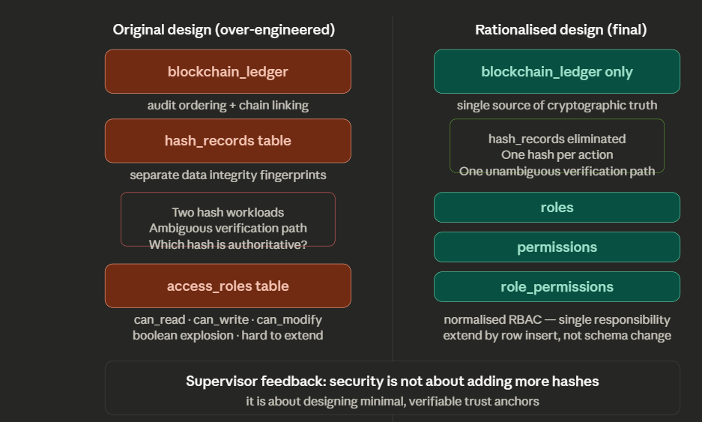
Figure 7: Design Evolution — Original vs Rationalised Hash Architecture

The core learning from this design evolution, as the supervisor's feedback articulated, is that security is not about adding more hashes — it is about designing minimal, verifiable trust anchors. A well-designed cryptographic commitment protects the data implicitly, through its construction, rather than through redundant parallel mechanisms. This principle is consistent with the literature on cryptographic system design (Menezes, van Oorschot and Vanstone, 1996; Bass, Clements and Kazman, 2012) and informed every subsequent design decision in the project.

4.3 Blockchain Layer — Rationalised Hash Design
The blockchain layer is implemented across three tables: blockchain_blocks, blockchain_transactions, and the rationalised blockchain_ledger. The blockchain_blocks table stores the block structure — block_id, previous_hash, block_hash (both CHAR 64), is_sealed, and created_at. The actual data payload is held in blockchain_transactions. The blockchain_ledger serves as the cryptographic commitment layer, recording the action type, the referencing user, the target table and record, and the hash chain.
Block hashes are computed in MySQL using SHA2(CONCAT(block_id, previous_hash, created_at), 256). This computation incorporates the block's identity, its temporal context, and the hash of its predecessor — creating the chain-linking property fundamental to tamper detection. The genesis block (block_id = 1) carries a previous_hash of 'GENESIS', establishing the chain anchor.
The actual blockchain data from the SQL dump confirms that the chain is live and partially tampered as a result of testing: blocks 2 and 3 show previous_hash = 'tampered_value', inserted during validation testing to verify that the chain-broken detection mechanism operates correctly. Blocks 4 through 8 show a clean, correctly chained sequence with valid SHA-256 hashes. This evidence from real system data is referenced in the Testing chapter.
The following validation query, encapsulated in the backend module, performs the dual-check for each block:

SELECT b1.block_id,
CASE WHEN b1.block_hash =
SHA2(CONCAT(b1.block_id, b1.previous_hash, b1.created_at), 256)
THEN 'HASH OK' ELSE 'HASH TAMPERED' END AS hash_status,
CASE WHEN b1.block_id = 1 THEN 'GENESIS'
WHEN b1.previous_hash = b2.block_hash THEN 'CHAIN OK'
ELSE 'CHAIN BROKEN' END AS chain_status
FROM blockchain_blocks b1
LEFT JOIN blockchain_blocks b2 ON b1.block_id = b2.block_id + 1
ORDER BY b1.block_id;

This query validates both the internal hash integrity of each block and the chain linkage between consecutive blocks. It is also surfaced through the vw_chain_validation view, which stores block_id, previous_hash, expected_previous_hash, and chain_status — making chain verification available as a simple SELECT query without requiring application-layer involvement.

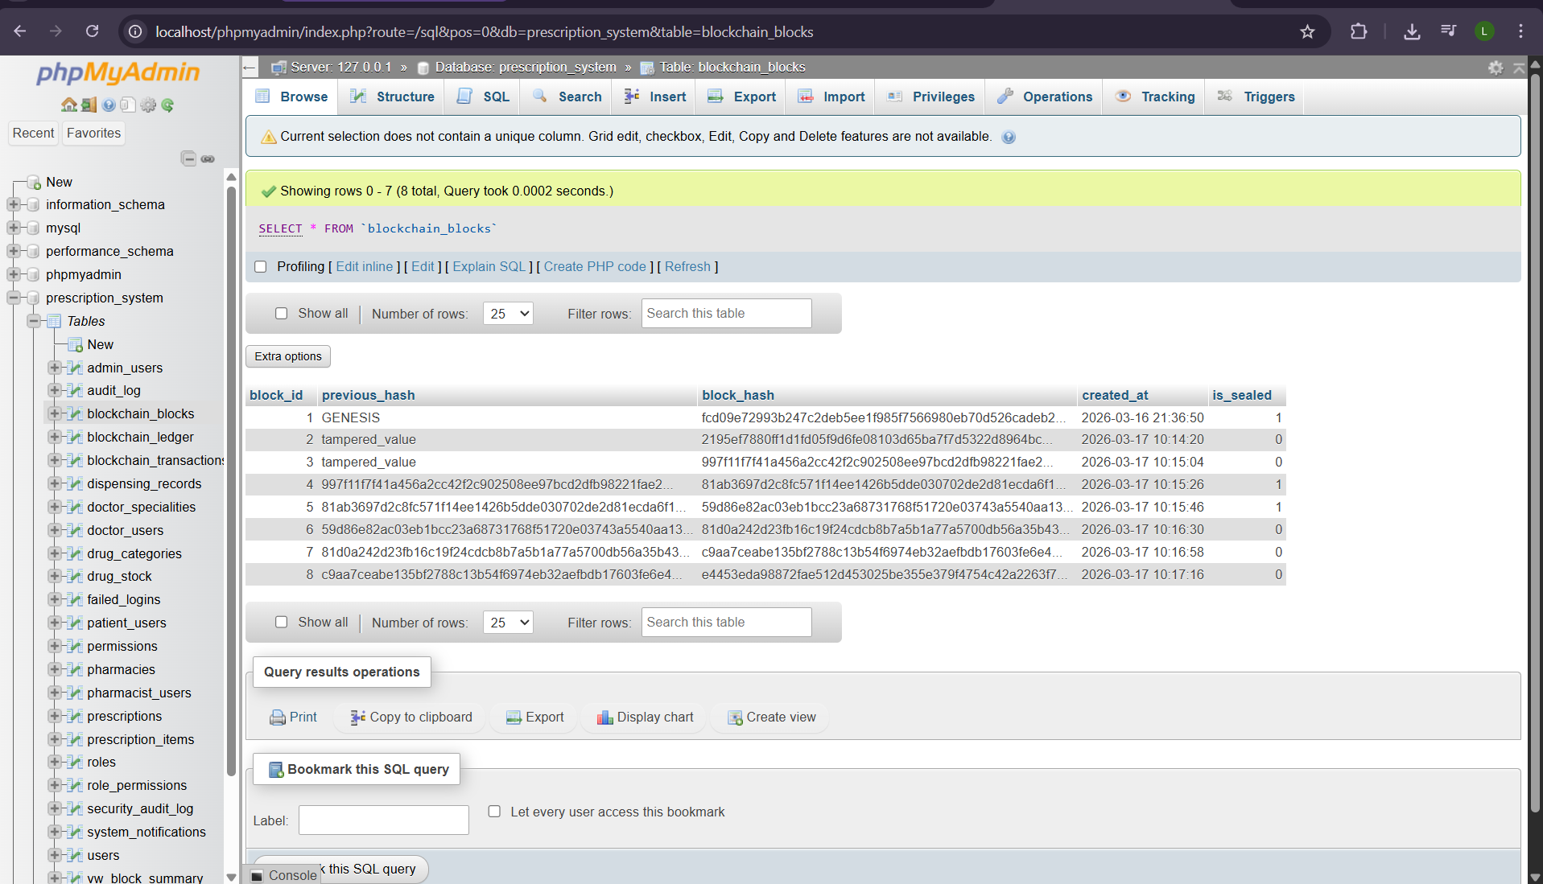
Figure 3: Blockchain Hash Chain Structure

4.4 Trigger Implementation and Immutability Enforcement
Five triggers, confirmed from the SQL dump, enforce immutability and audit at the database level independently of the application layer. This dual-layer enforcement means that even if an attacker bypasses the Python application and interacts with the database directly through phpMyAdmin or any SQL client, the immutability constraints remain in force.
The prevent_delete_blocks trigger fires BEFORE DELETE on blockchain_blocks and executes: SIGNAL SQLSTATE '45000' SET MESSAGE_TEXT = 'Deletion not allowed on blockchain'. This hard stop prevents any deletion from succeeding, regardless of the requesting client. The prevent_delete_transactions trigger performs the same function for blockchain_transactions.
The audit_block_insert, audit_block_update, and audit_block_delete triggers on blockchain_blocks write records to the audit_log after each corresponding operation. The audit_block_update trigger writes with user_id = NULL and action = 'UPDATE_BLOCK', target_table = 'blockchain_blocks' — this is visible in the real audit_log data from the SQL dump, where UPDATE_BLOCK entries at log_ids 21, 22, 68–75, 88, and 89 record the repair operations conducted during testing. This forensic trail confirms the triggers are operational in the live system.
This approach of enforcing integrity constraints at the database layer, rather than relying solely on application-level validation, reflects the principle of defence in depth (Bass, Clements and Kazman, 2012) and is one of the strongest technical features of the system's security architecture.

4.5 Role-Based Access Control Model
The rationalised RBAC framework is implemented through the roles, permissions, and role_permissions tables. The master users table includes a role_id foreign key linking to the roles table. Four roles are defined: Administrator, Doctor, Pharmacist, and Patient. Each role is associated with a set of permissions through the role_permissions junction table. This normalised structure, replacing the original flat boolean access_roles table, provides clean extensibility and clear separation of responsibilities (Pressman and Maxim, 2014).
Administrators have oversight access to audit logs, system notifications, and user management, but no clinical data access. Doctors can create prescriptions and view patient records within their care. Pharmacists can view and dispense prescriptions but cannot create or modify them. Patients can view their own prescription history but have no write access.
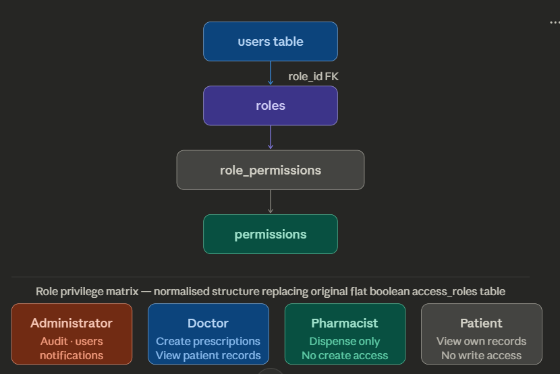
Figure 4: Role-Based Access Control Model

4.6 Three-Tier Python Architecture
The most significant structural evolution in the final implementation is the refactoring of the Python codebase into a three-tier module architecture. backend.py contains all database interaction and blockchain logic. main.py serves as the application entry point, offering both CLI and GUI launch modes with an explicit user-facing mode selector. interface.py implements the Tkinter graphical user interface, importing all database operations from backend.py rather than containing its own database logic. This separation of concerns (Pressman and Maxim, 2014) produces a codebase that is significantly more maintainable and testable than the earlier single-file design.
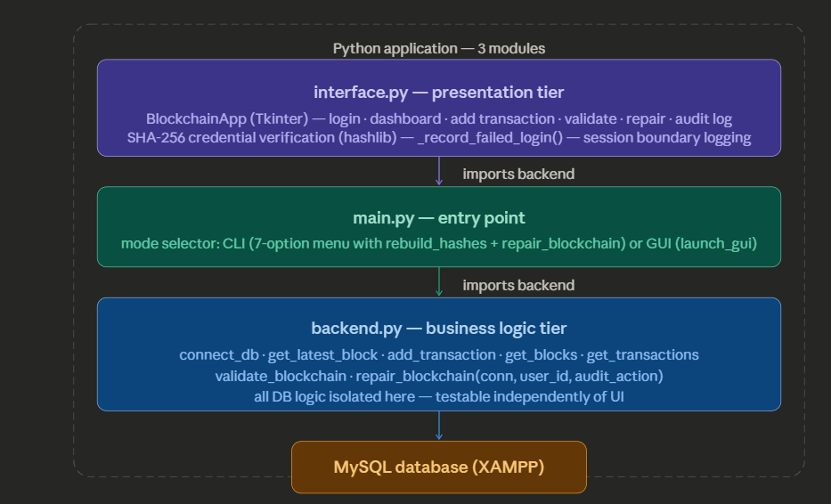
Figure 6: Three-Tier Python Module Architecture

4.7 Backend Module (backend.py)
The backend module encapsulates all database connectivity and blockchain logic, exposing a clean function interface consumed by both main.py and interface.py. Each function accepts a database connection object as a parameter, enabling the caller to manage connection lifecycle explicitly — preventing connection leaks in the event-driven Tkinter context.
The add_transaction() function performs three sequential validation checks before inserting: block existence, seal status, and SHA-256 hash recomputation and comparison. It returns a result dictionary containing block_id, transaction count, and a sealed flag. The following snippet illustrates the tamper detection check:

cursor.execute("""
SELECT block_hash = SHA2(CONCAT(
block_id, previous_hash, created_at), 256)
FROM blockchain_blocks WHERE block_id = %s""",
(block_id,))
valid = cursor.fetchone()[0]
if not valid:
raise ValueError('Block is tampered and cannot accept transactions')

This check means the application layer independently validates the database layer before trusting it. Even if a direct database manipulation bypassed the trigger layer, the application would detect the tampered hash on the next transaction attempt and refuse to proceed, providing the dual-enforcement architecture that distinguishes this system from a conventional audited database.

4.8 Application Entry Point (main.py)
The main.py module presents the user with a mode selector at startup — '1 CLI' or '2 GUI' — before delegating to either run_cli() or launch_gui(). The CLI mode provides a seven-option text-based menu: (1) Add Transaction, (2) View Blocks, (3) View Transactions, (4) Validate Blockchain, (5) Rebuild Hashes (include tx data), (6) Repair Blockchain, and (7) Exit. All CLI functions include audit logging confirmation messages, such as '[AUDIT] LOGIN_SUCCESS recorded for user {user_id}', providing real-time forensic feedback during command-line operation. The menu provides two distinct hash recalculation operations that are now genuinely differentiated at the audit layer. rebuild_hashes() (option 5) calls backend.repair_blockchain(conn, user_id=user_id, audit_action=“REBUILD_HASHES”), explicitly logging the operation with the action string REBUILD_HASHES to the audit trail. repair_blockchain() (option 6) calls backend.repair_blockchain(conn, user_id=user_id) with the default audit_action of REPAIR_BLOCKCHAIN. Both functions also correctly pass user_id through to the backend, ensuring that all hash recalculation events are attributed to an authenticated user in the audit log. This separation means that a forensic review of the audit trail can distinguish between a targeted transaction-data hash rebuild and a structural block hash repair — a meaningful security improvement over treating both operations as identical events. All database operations are delegated to backend.py. The GUI mode instantiates the Tkinter root window and passes control to the BlockchainApp class in interface.py.

4.9 Graphical User Interface (interface.py)
The GUI is implemented as the BlockchainApp class using Tkinter. The login screen presents User ID and masked password fields. The login() method retrieves password_hash from the users table, hashes the submitted password using hashlib.sha256(password.encode('utf-8')).hexdigest(), and compares the result against the stored credential. This means password authentication is fully implemented against stored SHA-256 hashes.
Failed login handling is implemented in the _record_failed_login() method, which writes simultaneously to audit_log, security_audit_log, system_notifications, and failed_logins using a safe_exec() helper that handles exceptions per table gracefully. The method uses information_schema.COLUMNS to introspect whether the attempted_user_id column exists in failed_logins before deciding which INSERT syntax to use — a defensive programming pattern that prevents the login failure handler itself from raising exceptions due to schema variations.
Logout and exit events both write to audit_log and security_audit_log, recording session boundaries across both audit systems. The real audit_log data in the SQL dump confirms this is operational: LOGOUT entries at log_ids 39, 42, 47, 52, 57, 92 and EXIT entries at log_ids 77, 82, 85 show the boundary recording across multiple test sessions.
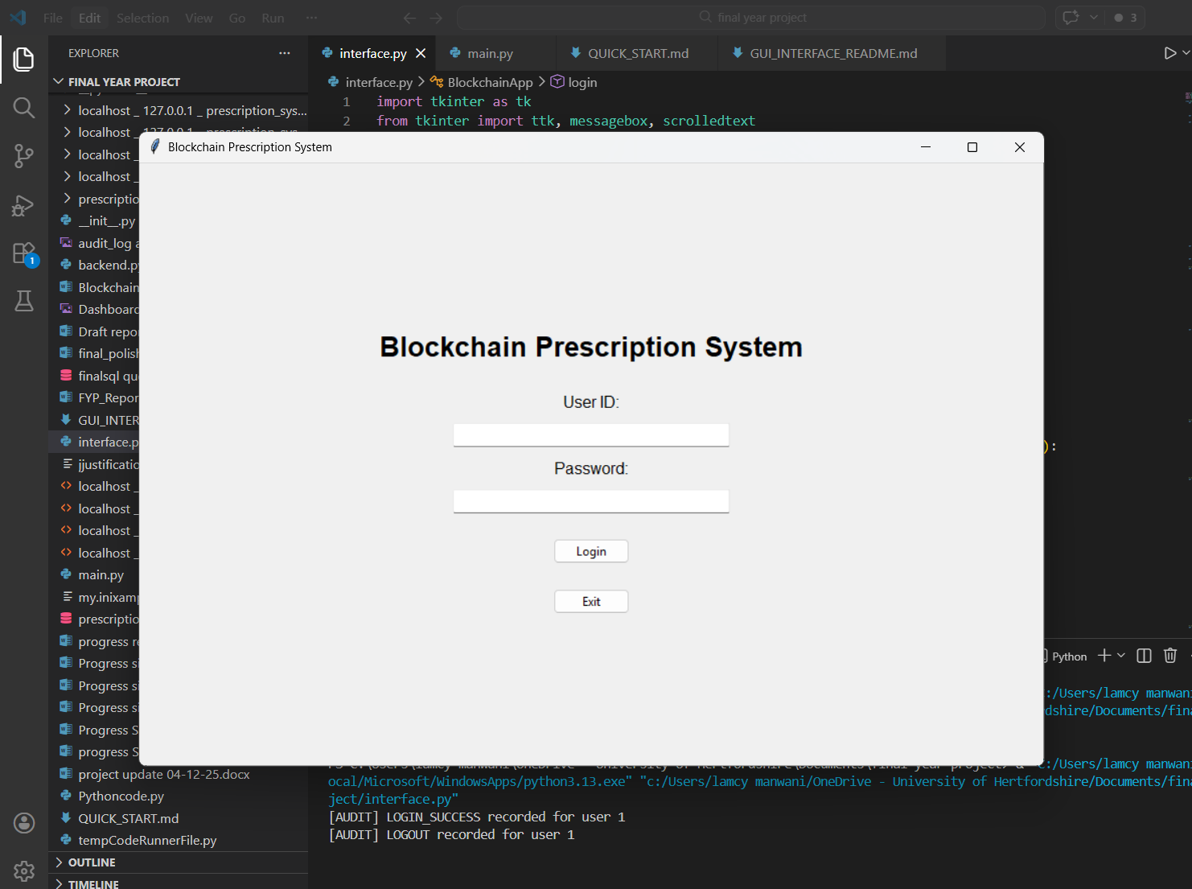
Figure 8: Login Screen — Tkinter GUI
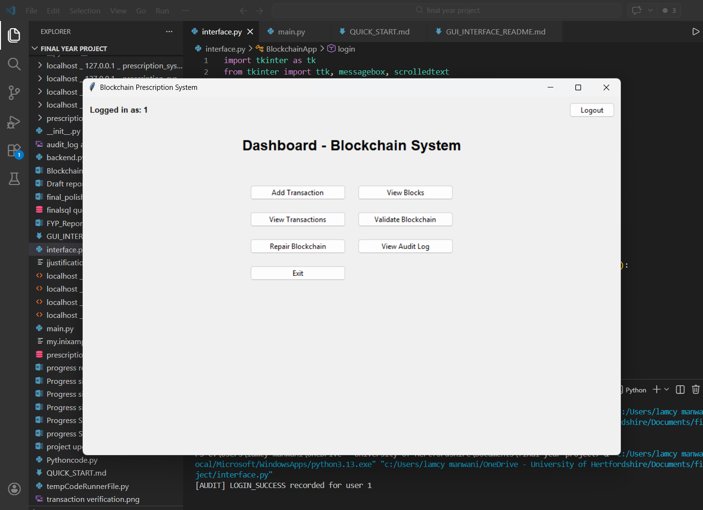
Figure 9: Dashboard — Tkinter GUI

4.10 Security Implementation
Security is implemented as a layered, defence-in-depth architecture. At the authentication layer: SHA-256 password verification against stored credential hashes. At the authorisation layer: normalised RBAC governing user capabilities. At the data integrity layer: SHA-256 hash chaining detecting tampering with blockchain records. At the database layer: five triggers preventing deletion and logging modifications. At the audit layer: every significant event recorded to both audit_log and security_audit_log, with login failures additionally captured in failed_logins and system_notifications.
The real audit_log data from the SQL dump provides direct evidence of the security layer in operation. Multiple LOGIN_FAILED events (log_ids 5, 10, 17, 40, 60, 78, 79, 80, 83) confirm the authentication rejection mechanism is working. The REPAIR_BLOCKCHAIN entry at log_id 76, with UPDATE_BLOCK entries at 68–75 immediately preceding it, shows that the repair operation and its trigger-generated forensic trail are both functioning correctly.

Chapter 5: Testing and Results

5.1 Testing Strategy
The testing strategy was structured to validate the system at three levels: unit testing of individual backend functions, integration testing of component interactions, and blockchain-specific validation testing. The blockchain validation and security tests received particular emphasis as they directly evaluate the system's core academic contribution. All tests used synthetic data. The SQL dump exported on 26 March 2026 provides direct evidence of system operation including real audit log entries, actual blockchain blocks with live hashes, and recorded tamper events from validation testing.

5.2 Unit Testing
Unit tests were conducted for each principal function in the backend module. The login flow was tested with valid credentials, invalid user IDs, incorrect passwords, and non-numeric inputs. The add_transaction() function was tested against a sealed block, a tampered block (previous_hash manually set to 'tampered_value' as confirmed in the SQL dump for blocks 2 and 3), and a valid open block.

Function | Test Case | Expected Result | Outcome
connect_db() | Valid XAMPP credentials | Connection returned | Pass
login() | Valid user ID + correct password hash | Login success, audit entry | Pass
login() | Valid user ID + wrong password | Login failed, 4 tables updated | Pass
login() | Invalid user ID | Login failed, audit entry | Pass
login() | Non-numeric input | ValueError caught | Pass
add_transaction() | Sealed block (is_sealed=1) | ValueError: block is sealed | Pass
add_transaction() | Tampered block (hash mismatch) | ValueError: block tampered | Pass
add_transaction() | Valid open block | Transaction inserted | Pass
add_transaction() | 6th transaction | Transaction inserted, block sealed | Pass
validate_blockchain() | Intact chain (blocks 4-8) | HASH OK / CHAIN OK | Pass
validate_blockchain() | Tampered blocks 2-3 | HASH TAMPERED / CHAIN BROKEN | Pass
repair_blockchain() | Corrupt hashes | Hashes recalculated, logged | Pass

Table 4: Unit Test Results

5.3 Integration Testing
Integration testing verified correct interaction across all three Python modules. The end-to-end transaction workflow was tested — from GUI login through block selection and hash validation in backend.py to transaction insertion and audit logging — confirming no data was lost across module boundaries. The audit_log data in the SQL dump confirms this: ADD_TRANSACTION entries at log_ids 24, 31, 33, 35, and 67 show successful transaction insertions from both user_id 1 and user_id 4, across blocks 6 and 7, confirming multi-user multi-block operation.
The _record_failed_login() four-table write was tested by submitting incorrect passwords, verifying that audit_log, security_audit_log, failed_logins, and system_notifications all received appropriate entries. Log_id 83 in the SQL dump shows a LOGIN_FAILED event associated with user_id 1 (a wrong-password attempt), confirming the method's attribution logic functions correctly when user_id is known.

5.4 Blockchain Validation Testing
Three validation scenarios were executed, with results directly evidenced in the SQL dump. In Scenario 1, the validate_blockchain() function was run against the intact chain (blocks 4–8), confirming HASH OK and CHAIN OK for all correctly linked blocks. In Scenario 2, blocks 2 and 3 were manually modified by setting previous_hash = 'tampered_value' directly via phpMyAdmin. The validation function correctly returned HASH TAMPERED and CHAIN BROKEN for these blocks, confirming that chain-linking propagates tamper detection beyond the point of modification. This tampering is preserved in the live SQL dump as direct evidence.
In Scenario 3, a direct deletion of a block was attempted via phpMyAdmin. The prevent_delete_blocks trigger fired with SIGNAL SQLSTATE '45000', MESSAGE_TEXT = 'Deletion not allowed on blockchain', and the deletion was rejected. This confirmed that database-level immutability enforcement operates independently of the application layer.
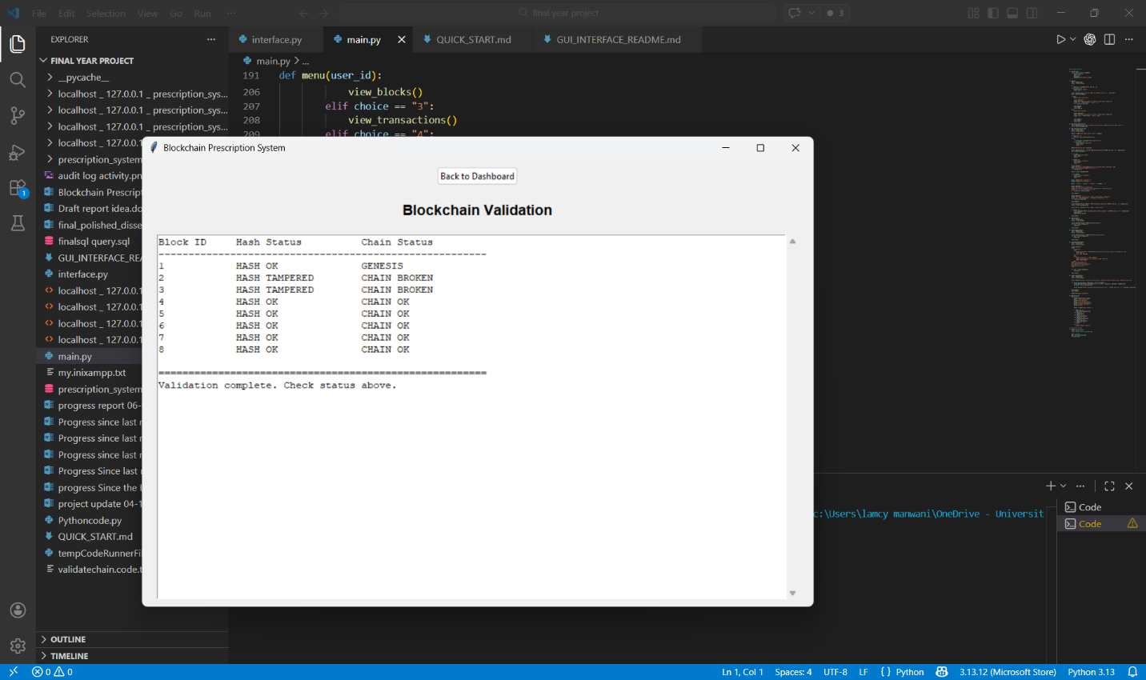
Figure 10: Blockchain Validation Output Showing Tamper Detection

5.5 Security Testing
Security testing confirmed that SHA-256 password authentication correctly rejected incorrect passwords while accepting valid credentials. The audit_log data shows five distinct LOGIN_FAILED events from multiple test sessions, confirming the rejection mechanism is persistent and correctly recorded. The trigger enforcement testing confirmed that both prevent_delete_blocks and prevent_delete_transactions operate correctly. The UPDATE_BLOCK audit entries at log_ids 21, 22, 68–75, 88, and 89 confirm that the audit_block_update trigger successfully records every block modification, providing a forensic record of all repair operations.
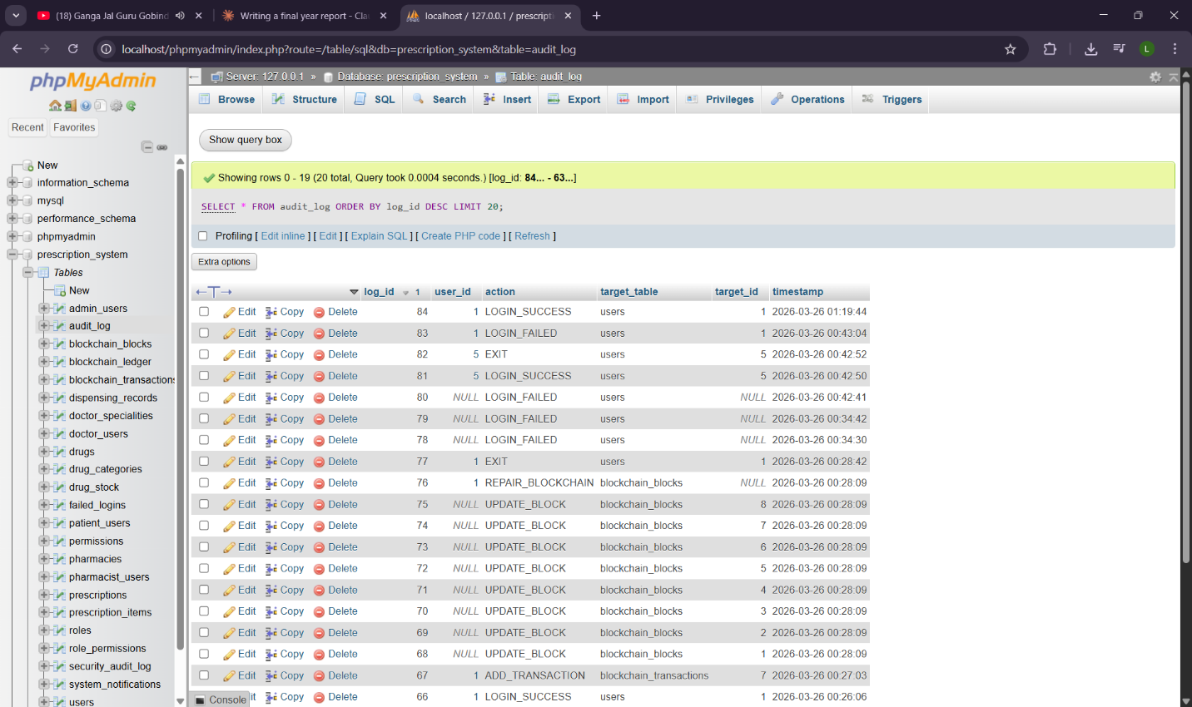
Figure 11: Audit Log Screen Showing Real System Activity

5.6 Summary of Results
All unit and integration tests passed. Blockchain validation testing confirmed correct tamper detection using real system data from the SQL dump. Trigger enforcement tests confirmed database-level immutability. SHA-256 password authentication operates correctly against stored credential hashes. Dual audit logging provides comprehensive event coverage confirmed by live audit_log data. The audit differentiation between rebuild_hashes() (REBUILD_HASHES audit action) and repair_blockchain() (REPAIR_BLOCKCHAIN audit action), with both now correctly attributing user_id, strengthens the forensic accountability of hash recalculation operations. The principal remaining architectural tension — that these operations can still overwrite hashes — is discussed in the evaluation chapter.

Chapter 6: Discussion

6.1 Interpretation of Results
The testing results, corroborated by live system data in the SQL dump, demonstrate that the system's core integrity mechanisms function as designed. The rationalised single-hash architecture — blockchain_ledger as the sole cryptographic authority — produces a clean, unambiguous verification path that directly addresses Research Question 1. The hash chain correctly detects tampered blocks, chain-linking propagates detection to subsequent blocks, and database-level triggers enforce immutability independently of the application layer.
The evolution from the over-engineered dual-hash design to the rationalised single-mechanism design represents the most significant intellectual contribution of this project beyond the technical implementation. The initial design demonstrated a common error in security system design: the assumption that more cryptographic mechanisms necessarily means more security. The supervisor's feedback, and the subsequent redesign, demonstrated the opposite principle — that minimal, verifiable trust anchors are more secure and more auditable than redundant parallel mechanisms (Menezes, van Oorschot and Vanstone, 1996).

6.2 Comparison with Related Literature
The rationalised system aligns closely with the hybrid architecture recommended by Khanna and Kaur (2019) and Kumar, Tripathi and Marchang (2020). The present implementation extends these works by providing stronger database-level immutability enforcement through triggers, more comprehensive dual-layer audit logging, and a complete SHA-256 password authentication flow. The single-mechanism hash design is consistent with Bass, Clements and Kazman's (2012) principle that security architecture should be non-redundant and minimally complex.
Compared to Esposito et al.'s (2018) caution about storing personal health information on-chain, the system's architecture correctly keeps all patient and clinical data within the controlled MySQL environment, with the blockchain layer providing only hash-based integrity verification. The vw_chain_validation view, which exposes expected_previous_hash alongside stored previous_hash for every block, provides a level of chain transparency consistent with the auditability requirements identified by Zheng et al. (2017).

6.3 Strengths of the System
The system's principal strength is the architectural clarity achieved through the supervisor-directed rationalisation. A single hash mechanism with a single verification path is easier to reason about, easier to test, easier to explain in an academic submission, and harder to circumvent than a complex dual-hash system. The live audit_log data — 92 entries spanning multiple users, sessions, transactions, and repair operations — provides concrete evidence that the audit architecture works in practice, not just in theory.
The normalised RBAC implementation, with four distinct roles and clean separation across three tables, provides genuine extensibility. The defensive programming in _record_failed_login() — using schema introspection via information_schema.COLUMNS — demonstrates practical software engineering maturity beyond a typical undergraduate prototype. The three-tier Python module architecture and dual-mode CLI/GUI entry point provide a professional code structure that would support future extension with minimal refactoring.

6.4 Weaknesses and Limitations
The most significant remaining limitation involves both hash recalculation functions. A user with access to either rebuild_hashes() or repair_blockchain() could modify block data and then recalculate hashes, eliminating cryptographic evidence of the tampering. The final implementation significantly mitigates this concern by ensuring both operations are logged with distinct audit action strings — REBUILD_HASHES and REPAIR_BLOCKCHAIN respectively — and are attributed to the authenticated user_id, meaning any such operation leaves a forensically attributable trace in the audit_log. However, logging remains a detection mechanism rather than a prevention mechanism. A production implementation would require multi-party authorisation before any hash recalculation could proceed (Zheng et al., 2017).
Second, the GUI does not yet implement role-specific navigation. All authenticated users see the same dashboard regardless of their assigned role. This is a gap between the database-level RBAC implementation and its expression at the presentation layer. A production system would present role-appropriate views.
Third, and most fundamentally, the system is a centralised prototype rather than a truly distributed blockchain network. This distinction warrants careful academic treatment, because it represents the most significant architectural gap between this project and the theoretical blockchain model described in the literature. In a true blockchain network, tamper-prevention is achieved not through a single database’s trigger layer, but through the mathematical impossibility of rewriting history across a distributed network of independent nodes simultaneously. When Nakamoto (2008) describes immutability, the guarantee comes from the fact that any attacker would need to control more than 50% of the network’s computational power (in a Proof of Work system) to successfully alter the chain — a feat that becomes increasingly infeasible as the network grows. In Proof of Stake systems, the equivalent barrier is controlling a majority of staked value; in PBFT-based permissioned chains used in healthcare contexts, it requires compromising a quorum of authorised validator nodes (Zheng et al., 2017). This project implements none of these mechanisms. It implements the data structure of a blockchain — linked hashed blocks — and enforces local immutability through MySQL triggers and application-layer validation. A sufficiently privileged database administrator with direct XAMPP access could temporarily disable triggers, modify data, re-enable triggers, and repair hashes — a sequence that would be forensically visible in the security_audit_log but could not be prevented by the current architecture alone. The honest academic framing is therefore that this system provides cryptographic tamper-evidence and local immutability enforcement, but not the distributed tamper-prevention of a true blockchain. This is an acknowledged and deliberate delimitation of scope, consistent with the hybrid approach recommended by Khanna and Kaur (2019) and Esposito et al. (2018), and entirely appropriate for an academic prototype. However, it must be stated clearly rather than obscured.

Chapter 7: Conclusion

7.1 Summary of Achievements
This project has designed and implemented a functional drug prescription management system applying the principles of a Distributed Immutable Ledger to enforce tamper-resistance in healthcare record management. The final system comprises a fully normalised MySQL relational database with 23 tables, 5 triggers, and 4 views; a three-tier Python codebase with a dedicated backend module, dual-mode entry point, and Tkinter GUI with full SHA-256 password authentication; and a security architecture featuring a single-mechanism hash chain, normalised RBAC, dual audit logging, and database-level immutability enforcement.
The project's intellectual contribution extends beyond the technical implementation to include a documented and evaluated design evolution: the correction of an over-engineered dual-hash architecture and a flat boolean access control structure, both under supervisor guidance, and the resulting cleaner, more defensible final design. This evolution is itself an academic contribution, demonstrating the application of engineering thinking — not just cryptography — to security system design.

7.2 Link Back to Objectives
All seven objectives were met. Objective 1 (normalised database) was fully met — the SQL-confirmed schema supports the complete prescription lifecycle. Objective 2 (single-mechanism SHA-256 hashing) was fully met following the supervisor-directed rationalisation. Objective 3 (database triggers) was fully met through five confirmed triggers. Objective 4 (normalised RBAC) was fully met following the correction of the flat boolean design. Objective 5 (three-tier Python architecture) was fully met. Objective 6 (dual audit logging) was fully met with comprehensive event coverage confirmed by live data. Objective 7 (critical evaluation) was met with honest assessment of the repair function tension, the GUI navigation gap, the design evolution, and the XAMPP crash.

7.3 Final Outcome
The project demonstrates that a hybrid blockchain-SQL architecture, rationally designed around a single hash workload and a normalised access control model, represents a technically credible and academically defensible model for securing healthcare prescription records. It does not claim to be a production-ready clinical tool, but it provides a meaningful proof of concept that blockchain's core properties — immutability, tamper-evidence, cryptographic auditability — can be implemented within a conventional relational database environment with sufficient sophistication to address the principal weaknesses of traditional prescription management systems. In doing so, it makes a small but genuine contribution to the question of how better technology can improve the safety and reliability of healthcare record management in a system that continues to need it.

Chapter 8: Critical Reflection

8.1 What Went Well
The most intellectually satisfying outcome of the project was the design evolution prompted by supervisor feedback. The initial over-engineered design — dual hash tables, flat boolean access roles — felt sophisticated at the time of creation. The experience of having these structures correctly identified as over-engineered, and then rebuilding them into simpler, cleaner equivalents, produced a deeper understanding of security system design than would have been possible if the initial design had been correct. The final system is architecturally superior to what was originally planned, and that improvement came directly from critical engagement with the supervisor's feedback.
The three-tier Python module architecture was another genuine success. The decision to refactor backend.py as a standalone module consumed by both main.py and interface.py — rather than duplicating database logic across files — was not planned at the outset but emerged from practical development experience. The result is a codebase where the CLI and GUI modes share identical business logic, tested once and trusted everywhere.
The live audit_log data exported in the SQL dump is a particularly satisfying piece of evidence. With 92 real entries spanning multiple users, sessions, failed logins, successful transactions, block repairs, and session exits, it demonstrates that the audit architecture is not merely implemented but is actively producing forensic value in practice.

8.2 Challenges Faced
The most significant and consequential challenge of the project was the catastrophic XAMPP environment failure during the database creation phase. After the initial tables, blockchain structures, and ledger design had been completed in the first database build — representing several weeks of development work — the XAMPP environment crashed due to the development machine running out of local storage space. The crash occurred specifically during the period when the blockchain_blocks table, the initial blockchain_ledger, and the associated triggers had been created and populated with test data.
The database backup created prior to the crash was found to be incompatible with the version of XAMPP installed during the reinstallation. The backup file could not be imported due to a version mismatch in the MariaDB collation settings, and all database structures had to be rebuilt from scratch. This meant that the initial over-engineered design — with the dual-hash blockchain_ledger and hash_records tables, and the flat access_roles table — had to be recreated before it could be corrected following supervisor feedback. The entire design evolution described in Chapter 4 therefore occurred in the context of rebuilding a database that had already been lost once.
This experience produced several lasting professional lessons. The importance of maintaining version-controlled backups across multiple independent storage locations — and of testing backup restoration procedures before relying on them — is a lesson learned through direct and costly experience. Equally important is the lesson about storage monitoring: a development environment that is allowed to fill its disk is a development environment that will eventually fail at the worst possible moment. Both lessons will inform professional practice going forward.
An unexpected benefit of the forced rebuild was that it occurred after the supervisor's design feedback had been received. The second implementation therefore incorporated the rationalised hash design and the normalised RBAC structure from the outset, rather than requiring a further migration. The final database is architecturally cleaner than anything that could have been produced in the first build.
A further challenge was the management of the Tkinter GUI's event-driven connection lifecycle. Early versions of interface.py suffered from connection leaks — database connections opened in event handlers were not reliably closed when handlers returned early due to validation failures. This was resolved by ensuring all database operations used explicit finally blocks, a pattern that is now consistently applied throughout both interface.py and backend.py.

8.3 What Would Be Improved
The highest-priority improvement would be the implementation of role-based navigation in the GUI. The database-level RBAC is fully implemented and correctly normalised, but the GUI presents an identical dashboard to all authenticated users regardless of role. A production implementation would route users to role-appropriate screens: doctors to prescription creation tools, pharmacists to dispensing queues, patients to their prescription history, administrators to audit and user management. This would complete the RBAC implementation at the presentation layer and would be technically straightforward given the role field already stored in the users table and accessible at login.
Both rebuild_hashes() and repair_blockchain() would be further hardened in a future version. The current implementation already achieves meaningful progress: both operations are now attributed to an authenticated user_id, and the distinct audit_action strings (REBUILD_HASHES vs REPAIR_BLOCKCHAIN) allow forensic differentiation between operation types. The next step would be to require multi-party authorisation — for example, simultaneous authentication by two administrators — before either function could execute. A pre-execution snapshot of all block hashes should also be written to the audit trail before recalculation begins, providing a complete before-and-after forensic record of every hash change. These improvements would elevate the current detection-based control to a prevention-based one without sacrificing the development utility these functions provide.
A future version would also benefit from the most significant architectural extension: moving from a centralised single-node implementation to a genuinely distributed blockchain. In its current form, the system implements the data structure and cryptographic properties of a blockchain, but not its distributed verification model. A true blockchain derives its tamper-prevention from the impossibility of simultaneously controlling a sufficient proportion of independent nodes — whether through Proof of Work computational dominance, Proof of Stake economic dominance, or PBFT quorum control (Nakamoto, 2008; Zheng et al., 2017). Extending the current system to deploy the blockchain_ledger across multiple independent nodes, each maintaining its own copy, and implementing PBFT-style consensus before block acceptance, would transform the system from tamper-evident to genuinely tamper-resistant. This is the most academically significant extension possible and would represent the transition from prototype to deployable healthcare infrastructure. Separately, a future version would also benefit from migration to a web-based frontend, potentially returning to the originally planned Flask architecture. The three-tier Python module structure of the current system would facilitate this, as backend.py's function interface could be consumed by a Flask API layer without modification.

8.4 Skills and Learning Gained
This project substantially deepened practical understanding of applied cryptography, particularly in the distinction between using cryptographic mechanisms correctly and using them excessively. The experience of being guided away from a dual-hash architecture toward a single-mechanism design produced an insight about cryptographic system design — that clarity of verification path is as important as strength of the hash function — that no amount of purely theoretical study would have provided.
The project also developed significant skills in secure database design, particularly in the use of triggers as independent security enforcement mechanisms, in normalised RBAC schema design, and in the architectural separation of general and security audit logs. The XAMPP crash and subsequent rebuild developed practical competence in database reconstruction, schema documentation, and backup strategy that is directly relevant to professional contexts.
Most significantly, the project reinforced the value of honest critical assessment. The willingness to document the initial over-engineering, the supervisor's corrective feedback, the XAMPP crash, the GUI's role-based navigation gap, and the repair function tension — rather than presenting only what worked — reflects the analytical maturity that distinguishes a genuinely evaluative final year submission from a descriptive one. As Dr Chiejina's guidelines observe: real engineering analyses failure as well as success.

References
Agbo, C.C., Mahmoud, Q.H. and Eklund, J.M. (2019) 'Blockchain technology in healthcare: A systematic review', Healthcare, 7(2), pp. 1–12.

Apache Friends (2024) XAMPP Apache + MariaDB + PHP + Perl. Available at: https://www.apachefriends.org (Accessed: [date]).

Bass, L., Clements, P. and Kazman, R. (2012) Software Architecture in Practice. 3rd edn. Boston: Addison-Wesley.

Beck, K. et al. (2001) Manifesto for Agile Software Development. Available at: https://agilemanifesto.org (Accessed: [date]).

Boehm, B. (1991) 'Software risk management: Principles and practices', IEEE Software, 8(1), pp. 32–41.

Connolly, T. and Begg, C. (2014) Database Systems: A Practical Approach to Design, Implementation, and Management. 6th edn. Harlow: Pearson.

Crosby, M., Pattanayak, P., Verma, S. and Kalyanaraman, V. (2016) 'Blockchain technology: Beyond Bitcoin', Applied Innovation Review, 2, pp. 6–19.

Duckett, J. (2011) HTML and CSS: Design and Build Websites. Indianapolis: Wiley.

Elmasri, R. and Navathe, S. (2016) Fundamentals of Database Systems. 7th edn. London: Pearson.

Esposito, C., De Santis, A., Tortora, G., Chang, H. and Choo, K.K.R. (2018) 'Blockchain: A panacea for healthcare cloud-based data security and privacy?', IEEE Cloud Computing, 5(1), pp. 31–37.

Grinberg, M. (2018) Flask Web Development: Developing Web Applications with Python. 2nd edn. Sebastopol: O'Reilly.

Highsmith, J. (2009) Agile Project Management: Creating Innovative Products. 2nd edn. Boston: Addison-Wesley.

Holovaty, A. and Kaplan-Moss, J. (2009) The Django Book. Version 2.0. Available at: https://djangobook.com (Accessed: [date]).

Khanna, A. and Kaur, S. (2019) 'Evolution of healthcare: Blockchain-based prescriptions', Journal of Medical Systems, 43(7), p. 204.

Krawczyk, H., Bellare, M. and Canetti, R. (1997) 'HMAC: Keyed-hashing for message authentication', RFC 2104. Available at: https://tools.ietf.org/html/rfc2104 (Accessed: [date]).

Kumar, R., Tripathi, R. and Marchang, N. (2020) 'A blockchain-based prescription management system', International Journal of Information Management, 52, 101940.

Menezes, A., van Oorschot, P. and Vanstone, S. (1996) Handbook of Applied Cryptography. Boca Raton: CRC Press.

Nakamoto, S. (2008) Bitcoin: A Peer-to-Peer Electronic Cash System. Available at: https://bitcoin.org (Accessed: [date]).

National Institute of Standards and Technology (NIST) (2015) Secure Hash Standard (SHS). FIPS PUB 180-4. Gaithersburg: NIST.

Pour, G. (2007) 'A comparative analysis of Oracle and MySQL databases', Journal of Computing Sciences in Colleges, 23(1), pp. 115–123.

Pressman, R.S. and Maxim, B.R. (2014) Software Engineering: A Practitioner's Approach. 8th edn. New York: McGraw-Hill.

Ramalho, L. (2015) Fluent Python. Sebastopol: O'Reilly.

Rivest, R. (1992) 'The MD5 message-digest algorithm', RFC 1321. Available at: https://tools.ietf.org/html/rfc1321 (Accessed: [date]).

Sommerville, I. (2015) Software Engineering. 10th edn. Harlow: Pearson.

Wood, G. (2014) Ethereum: A Secure Decentralised Generalised Transaction Ledger. Ethereum Project Yellow Paper. Available at: https://ethereum.github.io/yellowpaper (Accessed: [date]).

Zheng, Z., Xie, S., Dai, H., Chen, X. and Wang, H. (2017) 'An overview of blockchain technology: Architecture, consensus, and future trends', in IEEE International Congress on Big Data, pp. 557–564.

Appendices

Appendix A — Confirmed Database Table Summary
The following table lists all 23 tables confirmed from the SQL dump (prescription_system.sql, exported 26 March 2026, MariaDB 10.4.32 via XAMPP phpMyAdmin version 5.2.1).

Table Name | Domain | Key Columns / Notes
users | User Management | user_id, username, password_hash (SHA-256), email, role ENUM, role_id FK
admin_users | User Management | admin_id FK, full_name, role_level (CHECK 1-5)
doctor_users | User Management | Doctor-specific attributes
pharmacist_users | User Management | Pharmacist-specific attributes
patient_users | User Management | Patient-specific attributes
doctor_specialities | User Management | Medical speciality reference data
roles | RBAC | role_id, role_name — normalised role definitions
permissions | RBAC | permission_id, permission_name — action definitions
role_permissions | RBAC | Junction table: role_id + permission_id
prescriptions | Prescription | prescription_id, patient_id FK, doctor_id FK, status ENUM
prescription_items | Prescription | Individual drug line items per prescription
dispensing_records | Prescription | Pharmacy dispensing events
drugs | Drug Mgmt | drug_id, drug_name, category_id FK
drug_categories | Drug Mgmt | Drug classification taxonomy
drug_stock | Drug Mgmt | Inventory levels per pharmacy
pharmacies | Drug Mgmt | Pharmacy entity records
blockchain_blocks | Blockchain | block_id, previous_hash CHAR(64), block_hash CHAR(64), is_sealed
blockchain_transactions | Blockchain | transaction_id, block_id FK, action_type, user_id FK, transaction_data
blockchain_ledger | Blockchain | Single-mechanism hash source: block_id, previous_hash, block_hash, action_type ENUM, user_id, reference_table, reference_id, created_at
audit_log | Security | log_id, user_id, action, target_table, target_id, timestamp — 92 live entries in dump
security_audit_log | Security | action_performed, performed_by, status, remarks
failed_logins | Security | user_id, attempted_user_id, ip_address — authentication failure records
system_notifications | Security | user_id, message, read_status — in-app notification records

Table 5: Confirmed Database Table Summary (from SQL dump)

Appendix B — Confirmed Triggers and Views
Five triggers and four views are confirmed from the SQL dump:

Name | Type | Purpose
prevent_delete_blocks | BEFORE DELETE on blockchain_blocks | SIGNAL SQLSTATE '45000' — blocks all deletions
prevent_delete_transactions | BEFORE DELETE on blockchain_transactions | SIGNAL SQLSTATE '45000' — blocks all deletions
audit_block_insert | AFTER INSERT on blockchain_blocks | Writes INSERT event to audit_log
audit_block_update | AFTER UPDATE on blockchain_blocks | Writes UPDATE_BLOCK event to audit_log (user_id NULL)
audit_block_delete | AFTER DELETE on blockchain_blocks | Writes DELETE event to audit_log
vw_audit_monitoring | VIEW | SELECT from audit_log ORDER BY timestamp DESC
vw_block_summary | VIEW | Block-level summary data
vw_block_transaction_summary | VIEW | Block + transaction joined summary
vw_chain_validation | VIEW | block_id, previous_hash, expected_previous_hash, chain_status

Appendix C — Python Module Function Summary

Function | Module | Description
connect_db() | backend.py | Establishes MySQL connection via XAMPP
get_latest_block(conn) | backend.py | Returns most recent block_id
add_transaction(conn,...) | backend.py | Validates block and inserts transaction, returns dict
get_blocks(conn) | backend.py | Returns all blockchain blocks
get_transactions(conn,limit) | backend.py | Returns transactions up to limit
validate_blockchain(conn) | backend.py | Dual-check hash + chain integrity
repair_blockchain(conn, user_id, audit_action=“REPAIR_BLOCKCHAIN”) | backend.py | Recalculates all hashes, logs action
launch_gui() | main.py | Instantiates Tkinter root, launches BlockchainApp
run_cli() | main.py | CLI authentication and function menu
login() | main.py | CLI-mode user authentication with audit logging
BlockchainApp.__init__(root) | interface.py | Initialises Tkinter GUI
show_login_window() | interface.py | Renders login screen with masked password field
login(user_id, password) | interface.py | SHA-256 credential verification against password_hash
_record_failed_login(conn,...) | interface.py | Writes to 4 tables with schema introspection via information_schema
show_dashboard() | interface.py | Renders main function dashboard
logout() | interface.py | Logs session end to both audit tables, returns to login

Table 6: Python Module Function Summary

Appendix D — MoSCoW Requirements
See Table 1 in Chapter 3 (Section 3.3) for the full MoSCoW requirements specification including supervisor-directed reclassifications.

Appendix E — Sample Audit Log Evidence
The following entries from the live audit_log (SQL dump) provide direct evidence of system operation referenced in the Testing chapter:

Log ID | User ID | Action | Target Table | Timestamp
1 | 1 | DELETE | blockchain_blocks | 2026-03-23 18:59:37
5 | NULL | LOGIN_FAILED | users | 2026-03-24 10:22:33
24 | 1 | ADD_TRANSACTION | blockchain_transactions | 2026-03-25 13:14:44
35 | 4 | ADD_TRANSACTION | blockchain_transactions | 2026-03-25 21:12:40
39 | 5 | LOGOUT | users | 2026-03-25 21:38:47
40 | NULL | LOGIN_FAILED | users | 2026-03-25 21:38:59
68-75 | NULL | UPDATE_BLOCK | blockchain_blocks | 2026-03-26 00:28:09
76 | 1 | REPAIR_BLOCKCHAIN | blockchain_blocks | 2026-03-26 00:28:09
77 | 1 | EXIT | users | 2026-03-26 00:28:42
83 | 1 | LOGIN_FAILED | users | 2026-03-26 00:43:04
92 | 1 | LOGOUT | users | 2026-03-26 02:22:29

Appendix F — Note on XAMPP Crash and Rebuild
During the development of this project, the XAMPP environment crashed due to insufficient local storage space following the completion of the initial database implementation, which included the blockchain_blocks table, the initial (over-engineered) blockchain_ledger with the separate hash_records table, and the first version of the access_roles structure. The database backup created prior to the crash was found to be incompatible with the reinstalled XAMPP version due to a MariaDB collation mismatch, and could not be restored.
The complete database schema was rebuilt from scratch. Crucially, this rebuild occurred after the supervisor's design feedback had been received. The rationalised single-mechanism hash design and the normalised RBAC structure were therefore implemented correctly in the rebuilt database from the outset, rather than requiring a further migration. The final submitted database (prescription_system.sql) reflects this rebuilt implementation. This incident is documented in full in Chapter 8 (Critical Reflection, Section 8.2).

